When a student signs up for a class, that is a selected service that is tracked in Hourglass. Some of the other services that are provided ie. Student kits, student travel, student housing, and chaperoning are all other services that should be selected by the student/guardian even if they are required for the student to attend. Most of these services are not signed up by the
student/guardian and will need to be entered by the teacher/ facilitator. These are all tracked on our CTE Website https://cte.yksd.com/ in a google form.
How to have a student fill out the form:
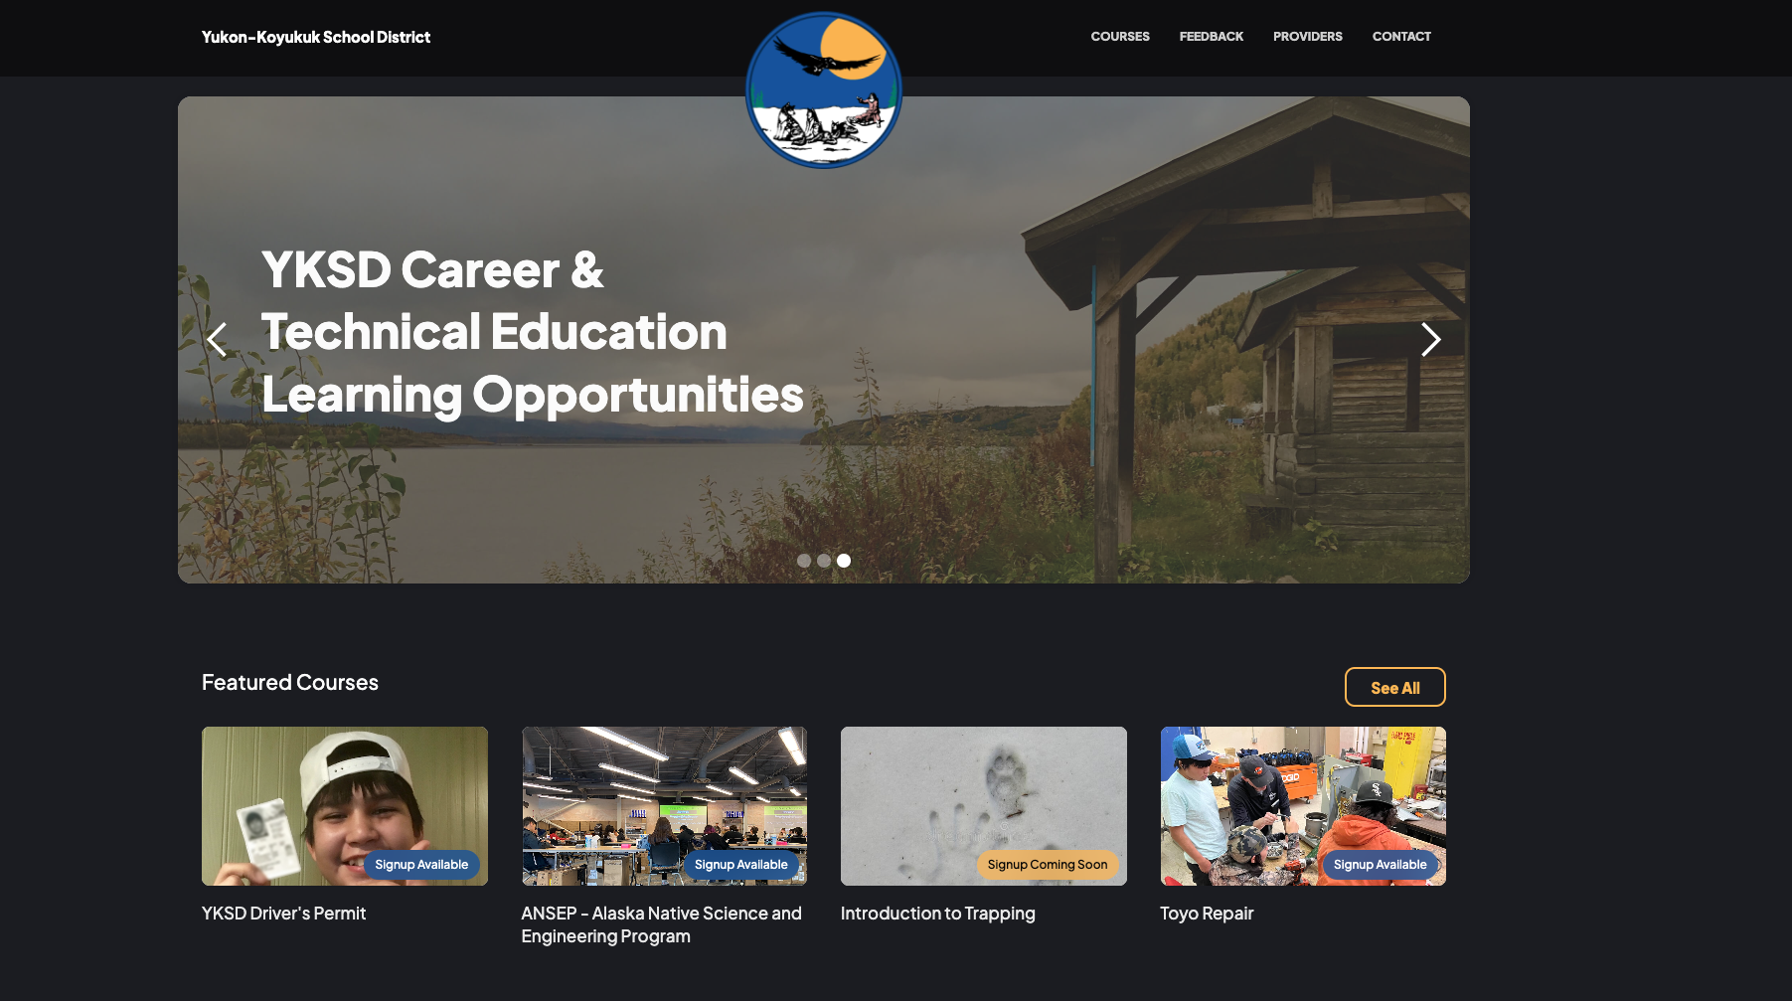

- Once you go to the website click on courses
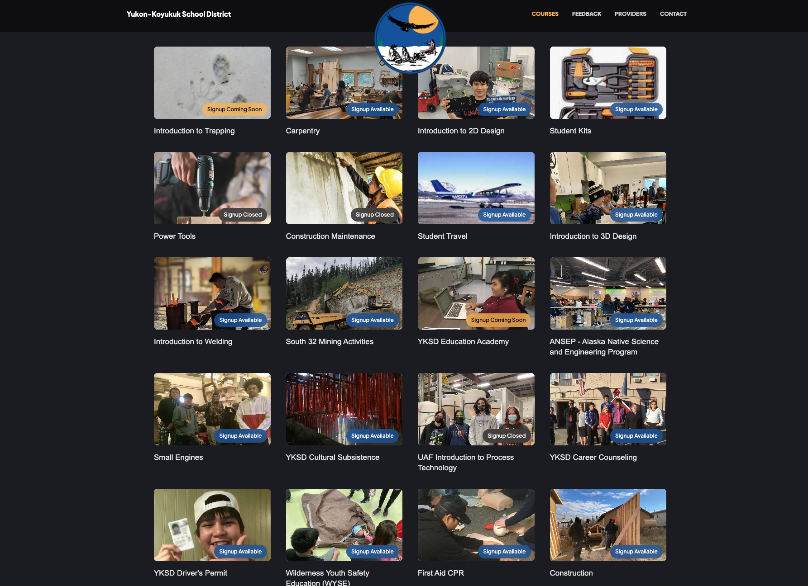
- Click on the services that are needed ie. Student kits or Student travel or in some cases you will have to do both

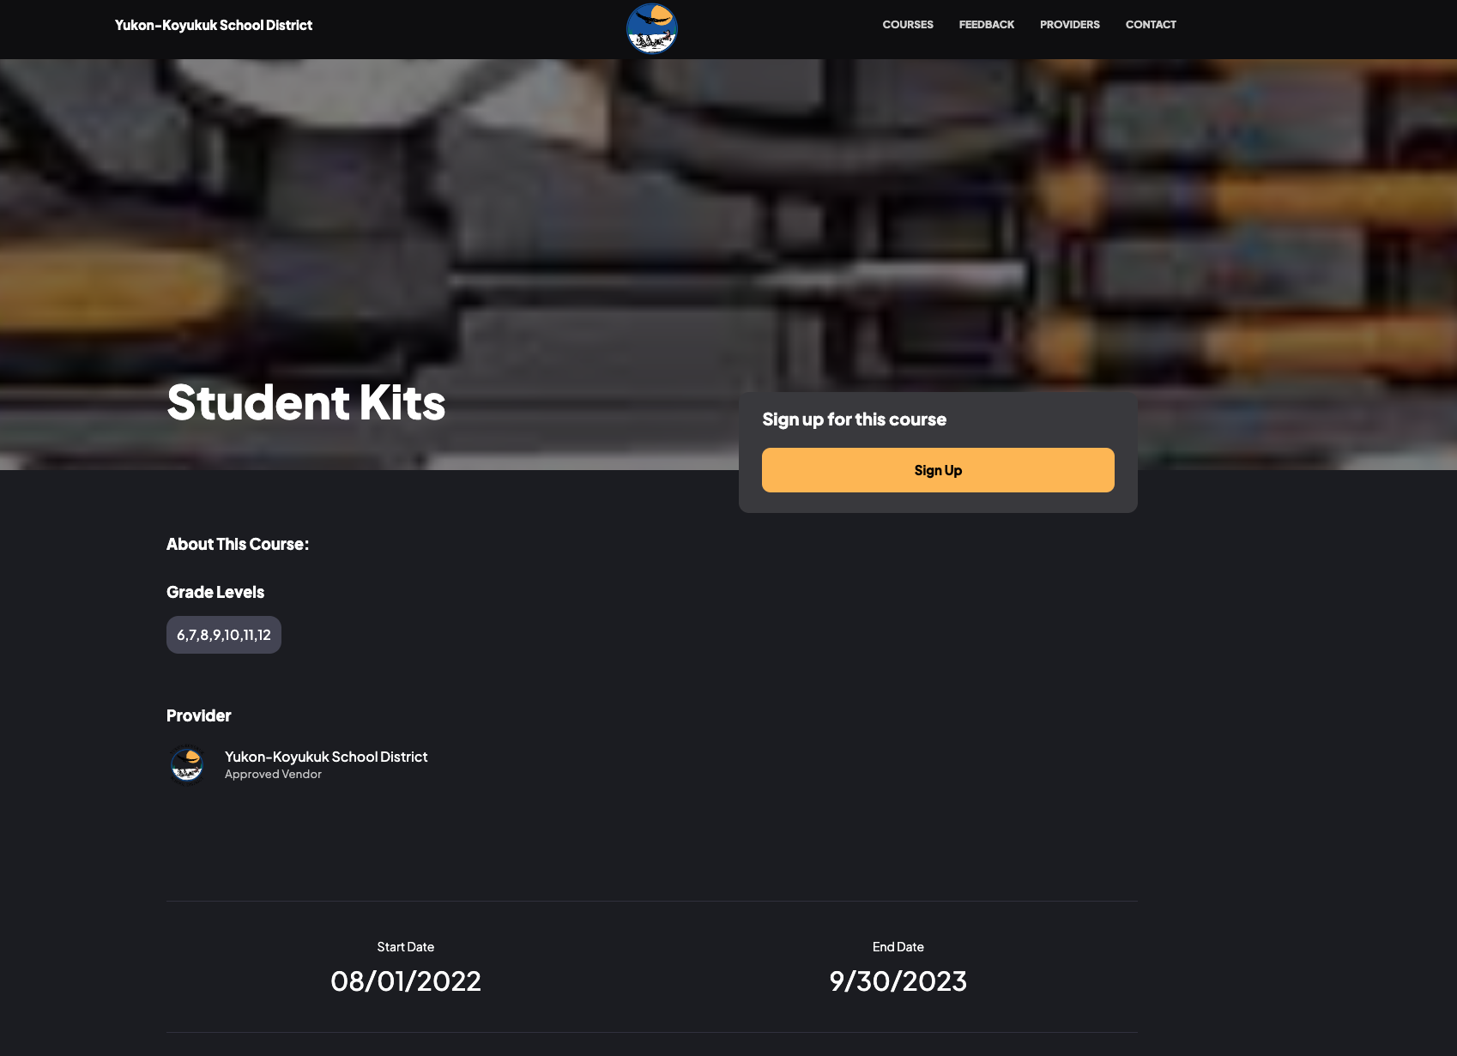
- Once you click on the course (Selected service) it will bring you to the menu screen and you will click on Sign Up. This will take you to the sign up form which is just a google document that you or the students will enter into the system

How to Quickly get to the form if you are filling it out

If you are filling out the form and want to quickly access the form you can go to
- Student Kits https://docs.google.com/forms/d/e/1FAIpQLSeDYRHxG4tYGkivVT_0VJUpue4qGpAsZp1lh20jg1SV5yDJhg/viewform
- Student Travel https://docs.google.com/forms/d/e/1FAIpQLSeDYRHxG4tYGkivVT_0VJUpue4qGpAsZp1lh20jg1SV5yDJhg/viewform

Eventually these services will not be tracked on the website as we are transitioning all data to hourglass but in the

