I**ngredients** **25 Servings 50 Servings 100 Servings**

Pancake Mix 25 50 100

(make according to pancake recipe)

Eggs, liquid frozen, thawed 6 ¼ C 12 ½ C 25 C

Cheese, shredded mozzarella 3 1/8 C 6 ¼ C 12 ½ C

Bacon pieces 3 1/8 C 6 ¼ C 12 ½ C

**Instructions**

1. Prepare pancakes according to pancake mix instructions. Cover with foil and keep warm in hotel pan or oven.
2. Heat large skillet on medium heat. Pour liquid eggs (thawed) in and cook until firm (about 1-2 minutes per 6 ¼ cups). Do not overcook. Remove from heat.
3. To assemble pacos, place pancake on hand and cup hand (to make a “U”). Layer the bottom with ¼ c egg, 1 teaspoon bacon, 1 tablespoon cheese. Stack side by side in separate hotel pan (reference picture below). Repeat until all 25 pacos are complete.

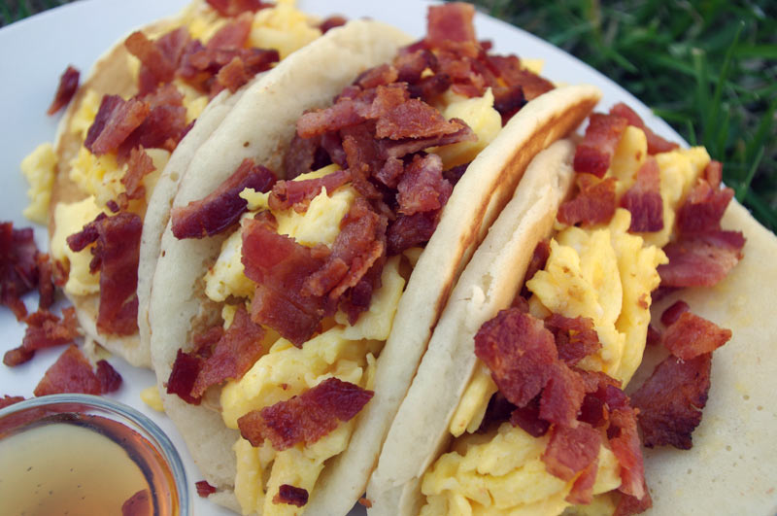

Serving Size: 2 pacos

**Nutrition**

Calories: 262 Saturated Fat: 4.75 Sodium: 554