**Ingredients** **25 Servings 50 Servings 100 Servings**

Ground beef, raw 4 lbs. 8 lbs. 16 lbs.

Orange juice 3 cups 6 cups 12 cups

Garlic powder 2 teaspoons 4 teaspoons 2 tablespoons

Brown Sugar 1 1/3 cup 2 2/3 cup 5 1/3 cup

Soy Sauce 1 1/3 cup 2 2/3 cup 5 1/3 cup

Sesame Oil ¼ cup ½ cup 1 cup

Ginger, ground 2 teaspoons 4 teaspoons 2 Tbsp + 2 teaspoons

Cornstarch 5 Tbsp ½ cup + 2 Tbsp 1 ¼ cup

Cooked rice 25 cup 50 cups 100 cups

Sliced green onion and sesame seeds for garnish

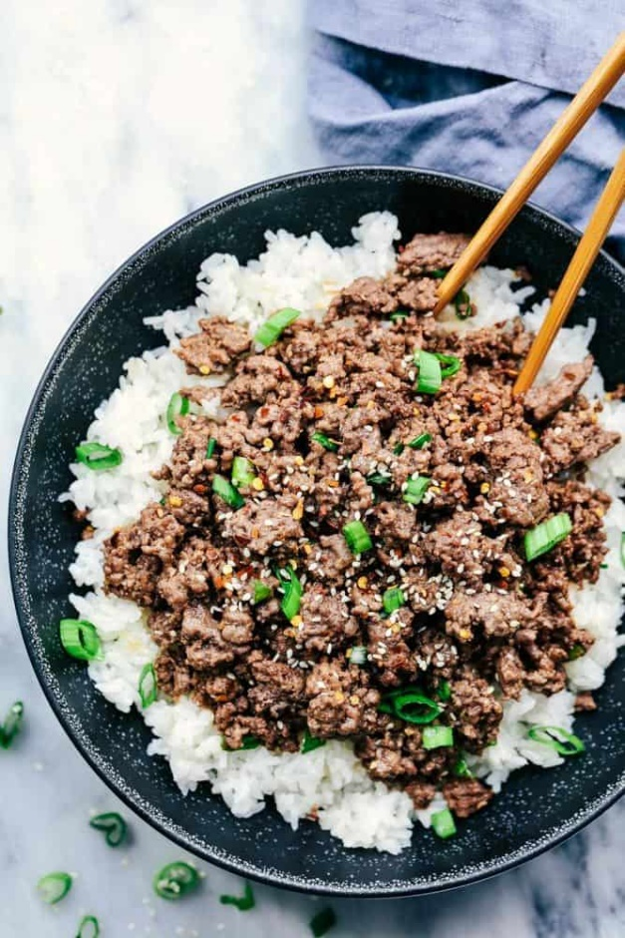

**Instructions**

1. In a large skillet cook the ground beef breaking it into crumbles over medium heat until no longer pink.
2. In a small bowl whisk together orange juice, garlic, brown sugar, soy sauce, sesame oil, ginger, and cornstarch. Pour over the ground beef and let simmer for another minute or two.
3. Serve over hot rice in bowl and garnish with green onions and sesame seeds.

**Serving size:** 1 cup rice = 2 oz WG, ¼ cup beef = 2 oz M/MA

**Nutrition**

Calories: 408.36 Saturated Fat: 3.28 sodium: 421