# 

## Employee Per Diem Rates

Any employee required to travel on District business (with the exception of student travel)

shall be paid per diem if travel extends beyond twelve (12) hours or requires overnight

stay away from their regularly assigned duty station. Employees traveling with teams as

paid or volunteer coaches, sponsors or chaperones, where meals and lodging are paid, shall

not receive any additional compensation.

Per diem is paid as follows:

12:01 A.M. to 8:00 A.M. $13.00

8:01 A.M. to 5:00 P.M. $20.00

5:01 P.M. to 12: 00 A.M. $29.00

## How to request a Per Diem

* A per diem advance may be requested through a Purchase Requisition.
* The requisition must be received 10 days prior to travel to ensure timely payment.
* CTE would prefer the Per Diem is put in after travel is completed to a ensure accurate pay out and lessen the change for an employee payback
* The amount of an advance is 100% of the per diem and 100% of mileage if using a personal vehicle.
* If a per diem advance is overpaid, the employee will have the option to reimburse the

district via a payroll deduction in the next pay period or pay with cash or check upon

completion of travel.

1.)Follow the steps included in [How to enter a requisition](https://drive.google.com/file/d/12h8px2a8o2oEYDRhxiDf2jjB-3U3vIgg/view?usp=share_link). See next page for an example of what it looks like

Should look like this when it is done

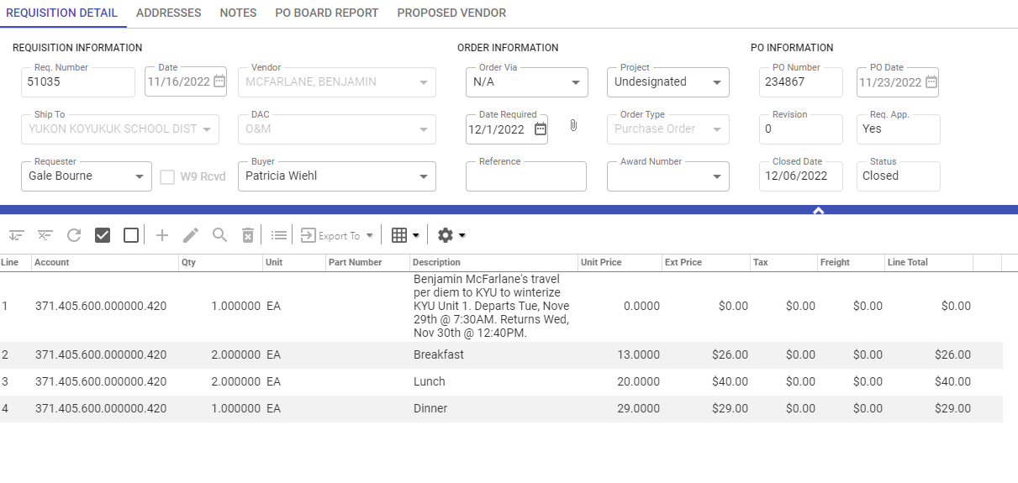

Once submitted for approval and received through Accounting you will be emailed the final PO. This will need to be submitted and signed to CTE Director Tom Hall. Once approved you forward it back to accounts payable so they are aware it is ok to pay.