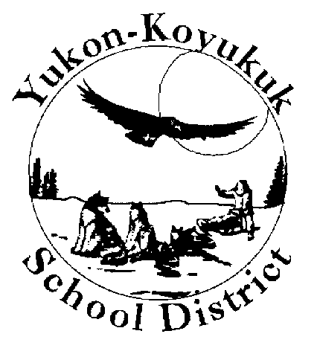 Yukon Koyukuk School District

Post Observation/Coaching Report

|  |  |
| --- | --- |
| Teacher Name: | School: |
| Coaches Name: | Date of Coaching: |
| Grade level and subject being taught while being observed | In one or two sentences, describe the lesson that you taught while the coach was in your classroom. |
| What did you hear the coach talk about during the coaching session? | What will you do differently because off the coaching session? |

Please complete this document within two days of your coaching session. Please email the completed report to [cbeam@yksd.com](mailto:cbeam@yksd.com).