I**ngredients** **25 Servings 50 Servings 100 Servings**

Tater Gems 5 lbs 10 lbs 20 lbs

Cream of Chicken Soup, condensed 2 cups 4 cups 8 cups

Cheddar Cheese, shredded 2 cups 4 cups 8 cups

Taco Meat, recipe 3 lbs 2 oz 6 lbs 4oz 12 lbs 8oz

Lettuce, shredded 12.5 cups 25 cups 50 cups (or 8 heads)

**Instructions**

1. Heat tater gems in oven according to package instructions, using hotel pan.
2. Cook taco meat according to “Taco Meat” recipe while tater gems are warming.
3. Keep tater gems in hotel pan and gently fold condensed cream of chicken soup into tater gems until barely mixed in, trying to not crush the tater gems.
4. Layer with ¾ cup cheese and all of taco meat.
5. Layer remaining ¼ cup cheese on top of taco meat.
6. Layer shredded lettuce on top when ready to serve.
7. Serve immediately.

**Notes**

* Serve each student with 1 oz sour cream, 1 individual serve ranch, and 1/8 cup salsa.
* Use 2 hotel pans for 25 servings, 4 hotel pans for 50 servings, and 8 hotel pans for 100 servings.
* Serving Size: 1 cup = 2oz M/MA, ¾ cup starchy vegetable

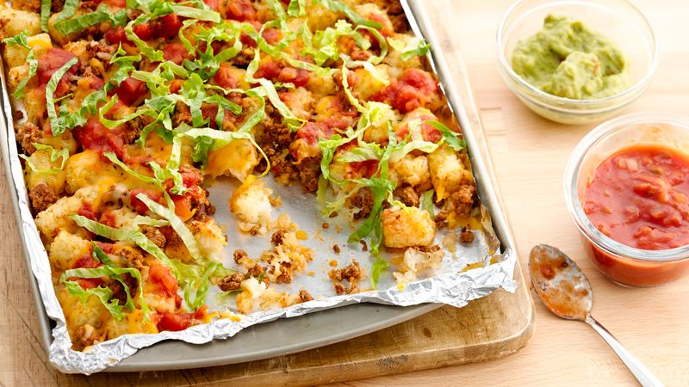**Nutrition Information**

Calories: 62 Saturated Fat: 1.98g Sodium: 228.9mg